How to use the Master Installer

SIL Software distributions come with a setup.exe file which controls the installation process. This program is known as the master installer. (In technical circles, it is known as a bootstrapper.)

The master installer allows the user to select which software to install, and handles all the dependency checks to make sure that prerequisite software also gets installed. It also provides the user with documentation to assist in the user’s decision as to which software to install.

SIL software is distributed both via the Internet and via CD. In the case of a CD, the master installer should auto-run when the CD is inserted into a drive. If it does not, the setup.exe program is located in the root directory of the CD, and must be launched manually. In the case of an Internet download, the package must be decompressed, and then the setup.exe program located and launched manually.

When the master installer runs, the first thing the user will see is typically something like this:
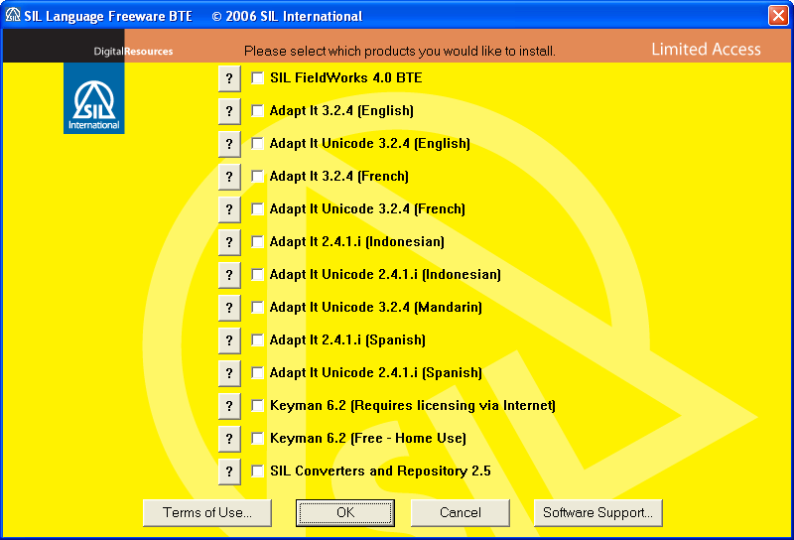

Note that the background color is important, and matches the color on the CD itself. In this case, yellow means that the software may be freely given away, but caution should be exercised, as some software may be inappropriate in some locations. A green background means that there is no sensitive software, and the software may be freely given away without caution:
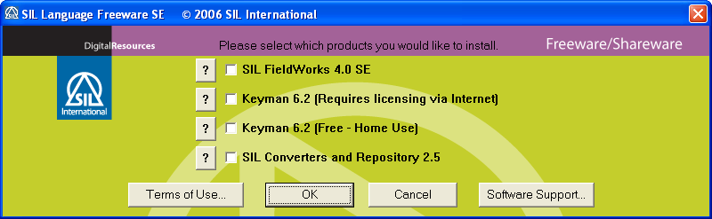

A red background means that the software may not be given away – it contains products only available to subscribers. A white or blue background means that the software may not be given away – it contains commercial products for which a royalty must be paid.

This first screen shows the list of software available in this particular software set. Each item has a button beside it. Pressing the button brings up a document explaining what the software is, along with any important advice for installing it. This should help users decide if they want to install the software.

If there is a button, then pressing it will bring up a document describing the licensing of the software.

If there is a button, then pressing it will bring up a selection of Service Bulletins, describing known issues with software related to this distribution.

The user should select each piece of software they want to install by clicking on its name or checkbox. If a piece of software is already installed, “(already installed)” will appear next to it. If there is some restriction prohibiting the installation, for example when administrator privileges are required but the current user does not have them, then the checkbox is disabled, and the reason for the prohibition is appended to the name of the software.

When the user has finished selecting software, the button should be pressed. The master installer will evaluate whether any prerequisite software must be installed first. If so, a list of the prerequisite software will be displayed in a dialog box. Software products will then be installed sequentially, in the order determined by the master installer.

During the installation of the software, a status window may be displayed, like this example:
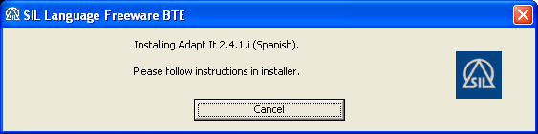

This window informs the user what the master installer is doing, and gives brief instructions to the user, where appropriate. The SIL logo on the right is an animated graphic. If it should “freeze” for a long period of time, the user should consider whether the machine has hung. The status window may disappear, usually when the user is required to devote full attention to the user interface of the current installer in the sequence.

Pressing the cancel button on the status window may not have the effect expected by the user. This cancel button is used to halt the overall sequence of product installation, but it cannot stop an individual installer from running. In the example above, pressing cancel will not stop the installation of Adapt It, but it will prevent any further selected software or prerequisites from being installed. In order to halt the Adapt It installation, the cancel button on the Adapt It installer must be pressed.

After the installation of the selected software, the master installer will evaluate whether any more software is required to support the installed applications. This often cannot be determined until after the selected software is installed, because it may depend on selections the user made while the product’s own installer was running. If any further software is required, a list will be displayed in a dialog box. This can sometimes lead to confusion, because the desktop shortcuts of the newly-installed software will be present at this time, yet the software may not be able to run, because other software that it is depending on is not yet present.

The user should wait until a “finished” message appears, before they attempt to run any newly-installed software. The message looks something like this example:
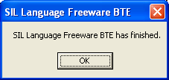

During the sequence of software installation, the computer may need to reboot. If the user is given a choice about when to reboot, the “reboot immediately” option should always be chosen. The user must not at this point quit the master installer, nor remove the CD (on a CD distribution). The master installer should start up where it left off after the reboot. If it does not, and the “finished” message has not been displayed, the setup.exe program must be restarted manually.

